CLOUD COMPUTING

Unit 1 — Introduction to Cloud Computing

1. What is Cloud Computing?
Cloud computing is a technology that allows users to access computing services such as servers, storage, databases, networking, and software over the internet instead of owning and maintaining physical hardware. These services are provided on demand and users pay only for what they use.
Cloud computing reduces cost, increases flexibility, and allows easy scalability of resources based on user requirements.
Examples:
- Google Docs allowing users to create and edit documents online without installing software
- Amazon Web Services (AWS) providing virtual servers and storage
- Microsoft Azure offering cloud-based application hosting and services

2. Vision of Cloud Computing
The vision of cloud computing is to treat computing resources like public utilities such as electricity or water.
Users should be able to:
- Access computing resources anytime
- Pay only for what they use
- Scale resources up or down easily
Key idea: Computing as a utility service.

3. Characteristics of Cloud Computing
Important exam question.
Characteristics of Cloud Computing:
- On-demand self-service: Users can access resources whenever required without human interaction.
- Broad network access: Services are available over the internet and can be accessed from devices like laptops, mobiles, and tablets.
- Resource pooling: Computing resources are shared among multiple users.
- Scalability: Resources can be increased or decreased easily based on demand.
- Measured service: Users are charged only for the resources they use.

4. Benefits of Cloud Computing
- Cost-effective: Reduces the need for expensive hardware and maintenance.
- Flexibility: Resources can be adjusted quickly as per user needs.
- High availability: Services are accessible anytime and from anywhere.
- Data backup and recovery: Cloud providers offer reliable data storage and recovery options.
- Easy collaboration: Multiple users can work on the same data simultaneously.

5. Challenges of Cloud Computing
Sometimes asked as disadvantages of cloud computing.
- Data Security and Privacy:
One of the major challenges in cloud computing is ensuring data security and privacy. Since data is stored on remote servers, there is a risk of unauthorized access, data breaches, and cyberattacks.
- Data Loss and Recovery:
Cloud systems may face data loss due to accidental deletion, hardware failure, or natural disasters. Although cloud providers offer backup solutions, data recovery is not always guaranteed.
- Dependence on Internet Connectivity:
Cloud services require a stable internet connection. Poor connectivity or network outages can prevent users from accessing cloud resources, affecting business operations.
- Compliance and Legal Issues:
Cloud data may be stored in different geographical locations, leading to legal and regulatory challenges. Organizations must ensure compliance with data protection laws and industry regulations.
- Vendor Lock-in:
Vendor lock-in occurs when users become dependent on a single cloud provider’s services and technologies. Migrating data or applications to another provider can be costly and complex.
- Limited Control and Flexibility:
Users have limited control over cloud infrastructure since it is managed by the cloud provider. This may restrict customization and system configuration.
- Performance Issues:
Cloud performance may vary due to shared resources and high traffic. Latency and downtime can affect application efficiency.
- Cost Management:
While cloud computing reduces initial costs, improper resource management can lead to unexpected expenses due to pay-as-you-use pricing.

6. Historical Development of Cloud Computing
Cloud computing evolved from earlier technologies.
Distributed Systems
Multiple computers work together to solve problems.
Virtualization
Allows multiple virtual machines to run on one physical machine.
Web 2.0
Enabled interactive web applications and online services.
These technologies together led to modern cloud computing.

7. Cloud Platforms
Cloud platforms provide infrastructure and services for hosting applications and managing data.
Examples of Major Platforms
Amazon Web Services (AWS)
- Provides IaaS and PaaS services
- Offers EC2, S3, RDS, Lambda
- Highly scalable and widely used
Microsoft Azure
- Supports application development and deployment
- Provides virtual machines, databases, AI services
Google Cloud Platform (GCP)
- Strong in data analytics and machine learning
- Provides Compute Engine, App Engine
IBM Cloud
- Enterprise cloud solutions
- Hybrid cloud support
These platforms offer computing resources, storage, networking, and software services.

Quick Revision (Important Points)
Cloud Computing provides:
- On-demand computing resources
- Internet-based services
- Pay-as-you-use model
Key characteristics:
- On-demand service
- Broad network access
- Resource pooling
- Rapid elasticity
- Measured service
Major platforms:
- AWS
- Google App Engine
- Microsoft Azure

Unit 2 — Principles of Parallel and Distributed Computing

1. Eras of Computing
Computing has evolved through several stages as technology advanced.
1. Mainframe Computing


- Early stage of computing.
- Large centralized computers used by organizations.
- Multiple users accessed the same system through terminals.
Features:
- Expensive hardware
- Centralized processing
- Used by governments and large companies

2. Personal Computing
- Computers became smaller and affordable.
- Individuals could own and operate personal computers.
Features:
- Standalone systems
- Desktop applications
- Increased accessibility

3. Distributed Computing
- Multiple computers connected through a network.
- Work is shared among several machines.
Advantages:
- Improved performance
- Resource sharing
- Fault tolerance

4. Cloud Computing

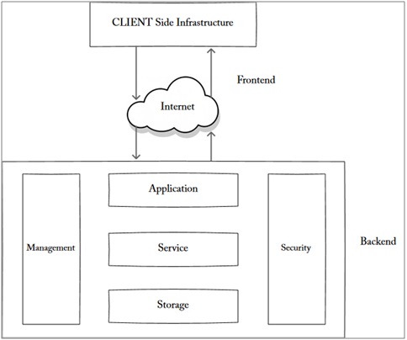

- Modern computing model.
- Resources delivered through the internet.
Features:
- On-demand services
- Scalability
- Pay-per-use model

2. Parallel Computing
Parallel computing is a technique where multiple processors perform several computations simultaneously.
Instead of completing tasks one after another, tasks are divided and executed at the same time.
Key Idea
Divide a large problem into smaller tasks and solve them simultaneously.
Example
Processing large scientific calculations or image rendering.
Advantages
- Faster processing
- Efficient use of processors
- Suitable for complex computations

3. Hardware Architectures for Parallel Processing
Parallel computing uses different hardware structures.
1. Shared Memory Architecture
- Multiple processors share the same memory.
- Communication occurs through shared memory.
Advantages:
- Easy communication
- Faster data sharing

2. Distributed Memory Architecture
- Each processor has its own memory.
- Processors communicate through messages.
Advantages:
- High scalability
- Suitable for large systems

4. Approaches to Parallel Programming
Two main approaches exist.
Data Parallelism
The same operation is performed on different parts of data simultaneously.
Example:
Processing thousands of images at once.
Task Parallelism
Different tasks are executed simultaneously.
Example:
One processor processes input while another performs calculations.

5. Distributed Computing
A distributed system is a collection of independent computers connected through a network that work together as a single coherent system to achieve a common goal.
The user sees it as one system, even though it consists of multiple machines.
Example: Cloud computing platforms, online banking systems, Google services.
Characteristics
- No shared memory
- Communication through network
- Resource sharing
- Scalability
- Fault tolerance

6. Components of a Distributed System
1️⃣ Nodes (Computers)
- Independent systems in the network
- Each node has its own CPU and memory
- Can act as client or server
Example: Multiple servers in a data center
2️⃣ Network
- Connects all nodes
- Enables communication
- Can be LAN, WAN, or Internet
Without network, it’s just lonely computers doing nothing useful.
3️⃣ Middleware
- Software layer between OS and application
- Manages communication and coordination
- Provides transparency
Functions:
- Naming services
- Security
- Synchronization
- Message passing
Example: CORBA, RPC systems
4️⃣ Distributed File System
- Allows files to be shared across systems
- Provides remote file access
Example: HDFS (Hadoop Distributed File System)
5️⃣ Communication System
- Enables message exchange
- Uses protocols like TCP/IP
- Supports IPC mechanisms
6️⃣ Application Layer
- Actual programs users interact with
- Runs on distributed infrastructure
Example: Online shopping systems
7. Architectural Styles for Distributed Computing
Distributed systems use different architectures.
Client–Server Architecture
One system (client) requests services from another system (server).
Example:
Web browser requesting data from a web server.

Peer-to-Peer Architecture
All nodes have equal roles and communicate directly.
Example:
File sharing networks.

8. Interprocess Communication (IPC)
Processes in distributed systems communicate using IPC mechanisms.
Common methods include:
- Message passing
- Remote procedure calls (RPC)
- Shared data
These mechanisms allow systems to exchange information.

9. Technologies for Distributed Computing
One important technology is Service-Oriented Computing.
In this model:
- Applications are divided into services.
- Services communicate over a network.
Example:
Web services and microservices.

10. Difference Between Parallel and Distributed Computing
(Very Important Exam Question)
Basis | Parallel Computing | Distributed Computing
Definition | Multiple processors execute tasks simultaneously within a single system | Multiple independent computers work together over a network
Physical Location | Processors are in the same machine | Computers are in different locations
Memory | Shared memory | Separate memory for each system
Coupling | Tightly coupled | Loosely coupled
Communication | High-speed internal communication | Network-based communication
Failure Impact | Failure may affect entire system | Failure of one node does not stop whole system
Scalability | Limited scalability | Highly scalable
Primary Goal | Increase speed of computation | Resource sharing and scalability
Example | Multi-core CPU, GPU | Cloud computing, distributed databases

Quick Revision Points
Parallel Computing:
- Multiple processors
- Simultaneous execution
- Faster computation
Distributed Computing:
- Multiple computers
- Connected through network
- Resource sharing
Important architectures:
1.Client–Server 2. Peer-to-Peer
Unit 3 — Virtualization

1. Introduction to Virtualization
Virtualization is a technology that allows one physical computer system to be divided into multiple virtual machines. Each virtual machine works like a separate computer with its own operating system and applications, even though they share the same hardware.
A software layer called a hypervisor manages these virtual machines.
This allows better utilization of hardware resources.

Virtualization Concept Diagram
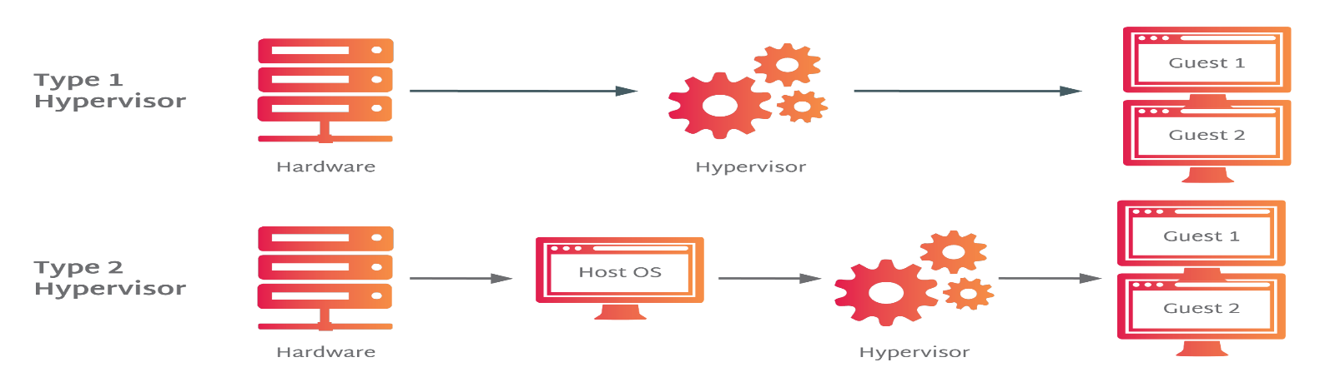

Explanation of Diagram
- Physical Hardware
The actual server with CPU, RAM, and storage.
- Hypervisor
Software that manages and allocates resources to virtual machines.
- Virtual Machines
Multiple independent operating systems running on one physical machine.
Each VM behaves like a separate computer.

2. Characteristics of Virtualized Environment
Important exam question.
1. Partitioning
A single physical system can run multiple virtual machines (VMs).
2. Isolation
Each VM is isolated from others. Failure in one VM does not affect others.
3. Encapsulation
A VM is stored as files. It can be copied, backed up, or moved easily.
4. Hardware Independence
VMs are not dependent on specific physical hardware.
5. Resource Sharing
CPU, memory, storage and network resources are shared efficiently.

3. Machine Reference Model
This model shows how virtualization works within a computer system.
It includes layers such as hardware, operating system, and applications.

Layers
- Hardware
Physical components like CPU, memory, storage.
- Operating System
Controls hardware and manages applications.
- Applications
Programs that run on the operating system.
Virtualization inserts a virtualization layer between hardware and operating systems.

4. Taxonomy of Virtualization Techniques
(Frequently asked exam question)
Virtualization techniques are classified into different types based on implementation.
1. Full Virtualization
The hypervisor completely simulates hardware.
Guest operating systems run without modification.
Example:
VMware
Advantages:
- High compatibility
- Multiple OS support

Full Virtualization Diagram
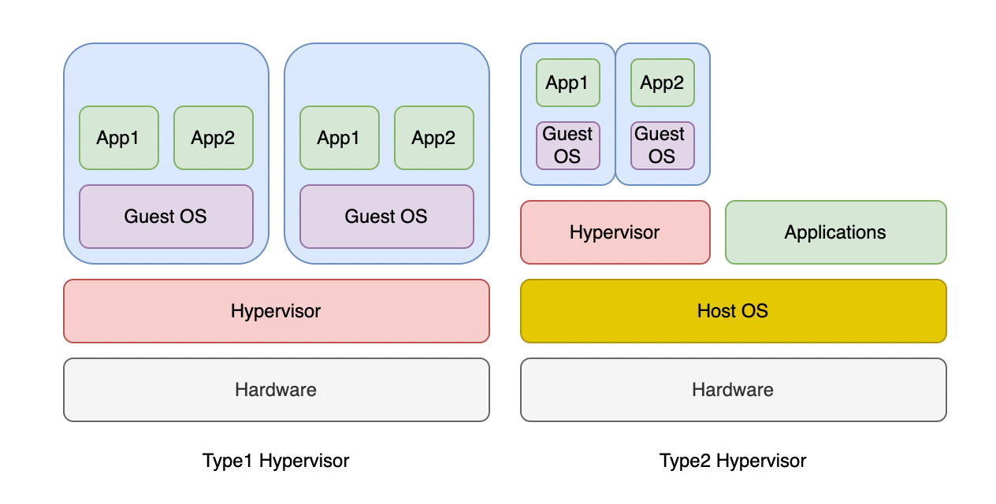

2. Para-Virtualization
The guest operating system is modified to communicate directly with the hypervisor.
Advantages:
- Faster performance
- Less overhead
Disadvantage:
- Requires modified OS.

3. Hardware-Assisted Virtualization
Modern CPUs include built-in virtualization support.
Examples:
- Intel VT-x
- AMD-V
Advantages:
- Better performance
- Improved security

🔹 Levels of Virtualization
1️⃣ Instruction Set Architecture (ISA) Level Virtualization
Definition:
Virtualization implemented at the processor instruction level.
Working:
It translates one machine’s instruction set into another using emulation.
Features:
- Simulates hardware architecture
- Allows incompatible systems to run
Example:
- Running ARM applications on x86 systems
- Emulators
Advantage:
High flexibility
Disadvantage:
Slower performance due to translation overhead

2️⃣ Hardware-Level Virtualization
Definition:
Virtualization implemented directly on hardware using a hypervisor.
Working:
Hypervisor divides hardware into multiple virtual machines.
Features:
- Each VM runs its own OS
- Strong isolation
- Efficient resource management
Example:
- VMware
- VirtualBox
- Hyper-V
Advantage:
High performance and strong isolation

Disadvantage:
Requires powerful hardware

3️⃣ Operating System-Level Virtualization
Definition:
Multiple isolated user-space instances share the same operating system kernel.
Working:
Instead of full VMs, containers are created.
Features:
- Lightweight
- Faster startup
- Shared kernel
Example:
- Docker
- LXC
Advantage:
Low overhead
Disadvantage:
All containers must use same OS kernel

4️⃣ Library-Level Virtualization
Definition:
Standard system libraries are replaced with virtualized versions.
Working:
Applications interact with a modified API layer.
Example:
- Wine (runs Windows apps on Linux)
Advantage:
Allows cross-platform compatibility
Disadvantage:
Limited compatibility

5️⃣ Application-Level Virtualization
Definition:
Applications run inside a virtual environment independent of underlying OS.
Working:
Application runs in a virtual runtime environment.
Example:
- Java Virtual Machine (JVM)

5. Other Types of Virtualization
Virtualization can also be applied to different resources.
Server Virtualization
Dividing a physical server into multiple virtual servers.
Storage Virtualization
Combining multiple storage devices into a single virtual storage system.
Network Virtualization
Creating virtual networks independent of physical infrastructure.
Desktop Virtualization
User desktops run on centralized servers instead of local computers.

6. Virtualization and Cloud Computing
Virtualization is the foundation of cloud computing.
Cloud providers use virtualization to:
- Run multiple virtual machines on servers
- Allocate resources dynamically
- Improve scalability and efficiency
Without virtualization, modern cloud platforms like
Amazon Web Services and Microsoft Azure would not work efficiently.

7. Pros and Cons of Virtualization
Advantages
- Better hardware utilization
- Reduced infrastructure cost
- Easy backup and recovery
- Improved scalability
- Energy efficiency

Disadvantages
- High initial setup cost
- Performance overhead in some cases
- Security risks if hypervisor is compromised
- Requires skilled management

Quick Revision
Virtualization means:
- Running multiple virtual machines on a single physical machine.
Main component:
- Hypervisor
Characteristics:
- Partitioning
- Isolation
- Encapsulation
- Hardware independence
Types:
- Full virtualization
- Para virtualization
- Hardware assisted virtualization

Unit 4 — Cloud Computing Architecture

1. Cloud Computing Architecture
Cloud computing architecture refers to the structure of components that deliver cloud services to users.
It includes:
- Front-end (user side)
- Back-end (cloud infrastructure)
- Internet network connecting them
Cloud Architecture Diagram


Components
1. Front-End
The client side where users interact with cloud services.
Examples:
- Web browsers
- Mobile apps
- Desktop software

2. Back-End
The infrastructure where cloud services run.
Includes:
- Servers
- Storage systems
- Databases
- Virtual machines

3. Network (Internet)
Connects the front-end and back-end.
Allows users to access cloud resources remotely.

2. Cloud Reference Model
The Cloud Reference Model explains how different cloud services are organized into layers.
It consists of three main service models.
Cloud Service Model Diagram
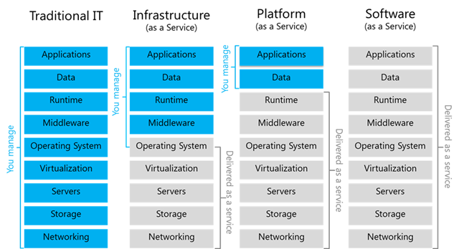

3. Infrastructure as a Service (IaaS)
IaaS provides virtualized computing resources over the internet.
Users rent infrastructure such as:
- Virtual machines
- Storage
- Networks
Examples:
- Amazon Web Services
- Microsoft Azure
Advantages:
- High flexibility
- Pay-as-you-go pricing
- Scalable resources

4. Platform as a Service (PaaS)
PaaS provides a platform for developers to build and deploy applications.
The provider manages:
- Infrastructure
- Operating systems
- Runtime environment
Developers only focus on coding.
Example:
- Google App Engine
Advantages:
- Faster development
- Reduced complexity
- Automatic scaling

5. Software as a Service (SaaS)
SaaS delivers software applications over the internet.
Users access applications through a browser without installing them.
Examples include services from companies like Google and Microsoft.
Examples:
- Google Docs
- Gmail
- Microsoft Office 365
Advantages:
- No installation required
- Accessible anywhere
- Automatic updates

6. Types of Clouds
Cloud computing environments are categorized into different deployment models.
The main types are:
- Public Cloud
- Private Cloud
- Hybrid Cloud
- Community Cloud

1️⃣ Public Cloud
🔹 Explanation:
Cloud services are provided to the general public over the internet by third-party providers.
🔹 Characteristics:
- Shared infrastructure
- Accessible via internet
- Pay-per-use model
- Managed by provider
🔹 Advantages:
- Low cost
- Highly scalable
- No maintenance required

🔹 Disadvantages:
- Less security
- Limited control
- Data privacy concerns
🔹 Example:
AWS, Microsoft Azure, Google Cloud

2️⃣ Private Cloud
🔹 Explanation:
Cloud infrastructure used by a single organization.
🔹 Characteristics:
- Dedicated resources
- High security
- Can be on-premise or hosted
🔹 Advantages:
- Greater control
- Better data security
- Custom configuration
🔹 Disadvantages:
- Expensive
- Requires maintenance
🔹 Used By:
Banks, government organizations

3️⃣ Hybrid Cloud
🔹 Explanation:
Combination of public and private cloud.
🔹 Characteristics:
- Data and applications move between clouds
- Flexible deployment
🔹 Advantages:
- Cost efficiency
- Better scalability
- Sensitive data can stay private
🔹 Disadvantages:
- Complex management
- Integration challenges

4️⃣ Community Cloud
🔹 Explanation:
Cloud shared by multiple organizations with similar needs.
🔹 Characteristics:
- Shared infrastructure
- Common security requirements
🔹 Advantages:
- Cost sharing
- Suitable for specific sectors
🔹 Disadvantages:
- Less flexibility
- Governance issues
🔹 Example:
Healthcare organizations sharing compliance infrastructure

🧠 Easy Memory Trick
Public → Everyone
Private → One organization
Hybrid → Mix of both
Community → Similar organizations

7. Economics of Cloud Computing
Key Economic Factors
1️⃣ Capital Expenditure vs Operational Expenditure
Type | Traditional IT | Cloud Computing
Capital Expense (CapEx) | Buy servers, storage, software | Mostly zero
Operational Expense (OpEx) | Maintenance, electricity, staff | Pay-per-use services
Memory trick: Cloud converts CapEx → OpEx

2️⃣ Pay-as-you-Use Model
- Users only pay for resources they consume.
- No idle resource costs.
- Flexible scaling reduces wasted expenditure.

3️⃣ Resource Pooling and Utilization
- Shared infrastructure increases efficiency.
- Multi-tenant systems optimize hardware usage.
- Reduces cost per user.

4️⃣ Elasticity and Scalability
- Scale resources up or down based on demand.
- Avoids over-provisioning and reduces unnecessary spending.

5️⃣ Maintenance and Staffing Costs
- Cloud provider manages hardware, updates, and security.
- Reduces in-house IT staff requirements.

6️⃣ Disaster Recovery & Business Continuity Savings
- Cloud services provide backup, replication, and high availability.
- Traditional DR setup is expensive.
- Reduces downtime costs.

🔷 Advantages from an Economic Perspective
- Reduced initial investment
- Flexible operational costs
- Faster ROI (Return on Investment)
- Less risk of under-utilized hardware
- Global access without building multiple data centers

🔷 Potential Economic Challenges
- Long-term subscription costs can add up
- Dependence on provider pricing
- Data transfer costs may be high

Quick Revision
Cloud Architecture includes:
- Front-end
- Back-end
- Internet network
Cloud Service Models:
- IaaS
- PaaS
- SaaS
Types of Clouds:
- Public cloud
- Private cloud
- Hybrid cloud
- Community cloud
Economic benefits:
- Pay-per-use
- Reduced hardware cost
- Scalability

